Open Wavy Shapes
# Source: AI Source: Provided by: [Data Path: Persons Table -> ID Column: 1, Name_En Column: Motasem Essam] -> From: [ChatGPT] on [7/25/2026]
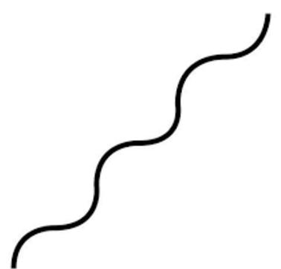
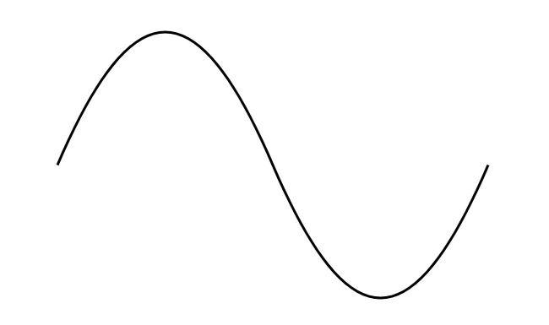
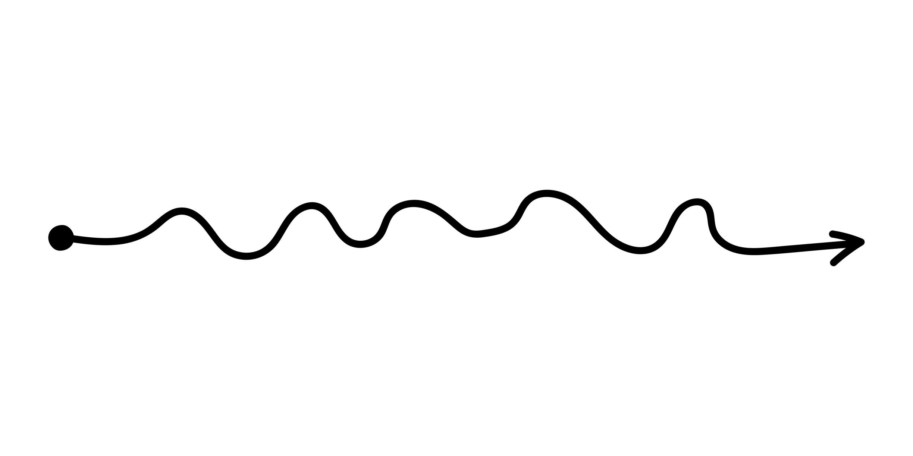
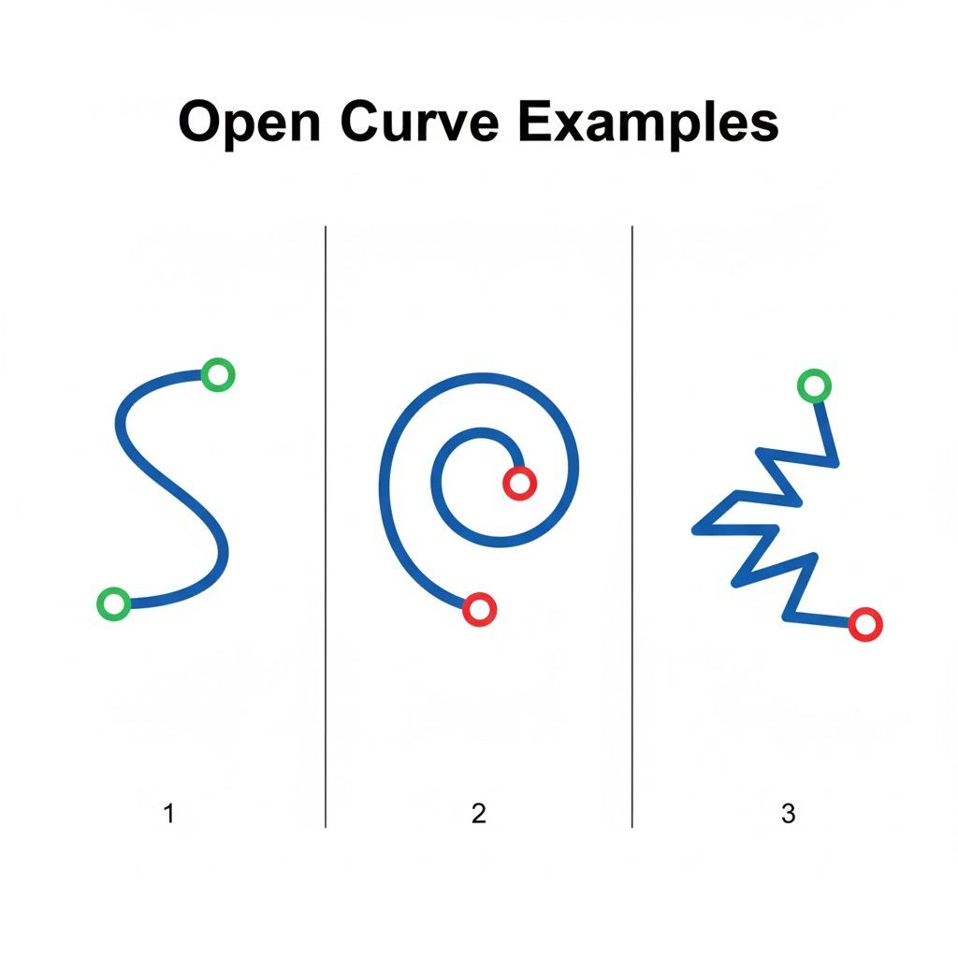
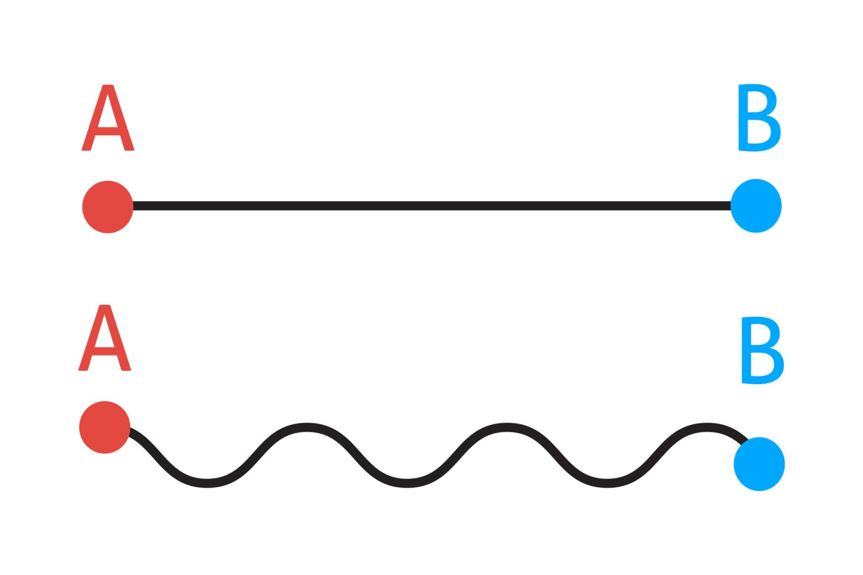
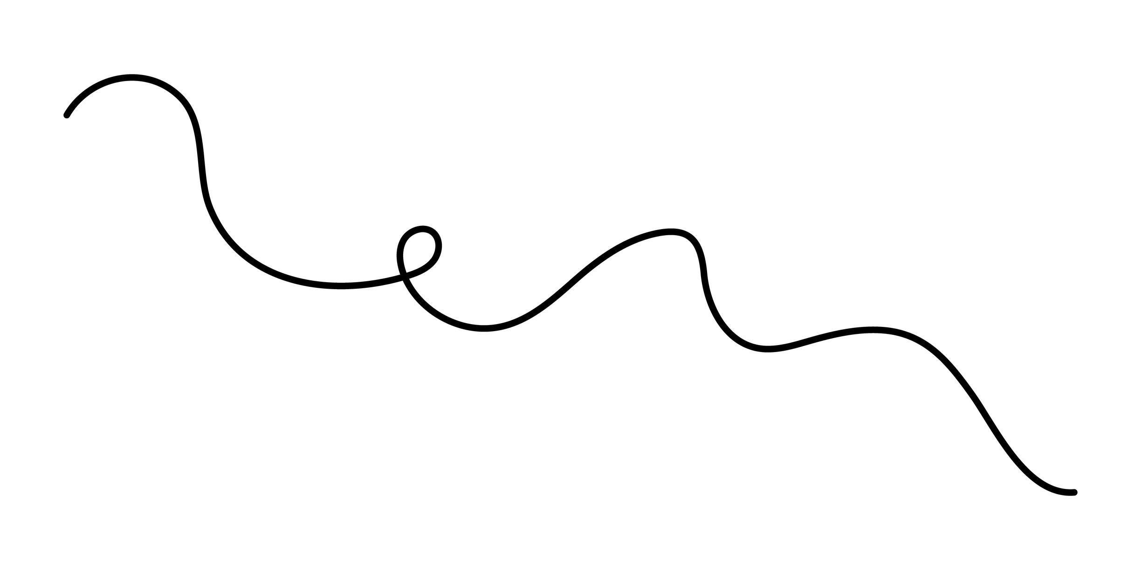

Definition
# Source: AI Source: Provided by: [Data Path: Persons Table -> ID Column: 1, Name_En Column: Motasem Essam] -> From: [ChatGPT] on [7/25/2026]
An Open Wavy Shape is a wavy form whose boundary or path does not close to form an enclosed region.
It usually consists of a smooth, continuously curved line that repeatedly rises and falls or changes direction in a wave-like manner.
Unlike a closed wavy shape, an open wavy shape has two distinct endpoints.

Fundamental Concept
# Source: AI Source: Provided by: [Data Path: Persons Table -> ID Column: 1, Name_En Column: Motasem Essam] -> From: [ChatGPT] on [7/25/2026]
An open wavy shape is created by a continuous or piecewise-smooth curve that follows a wave-like pattern.
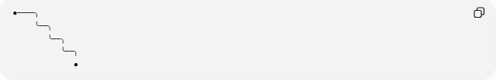
●────╮
╰──╮
╰──╮
╰──╮
●
The two endpoints remain unconnected.
A mathematical example is a portion of a sinusoidal curve:
$$y=Asin⁡\left(Bx+C\right)+D$$
where the curve is considered only over a limited interval of $x$.

Main Characteristics
# Source: AI Source: Provided by: [Data Path: Persons Table -> ID Column: 1, Name_En Column: Motasem Essam] -> From: [ChatGPT] on [7/25/2026]
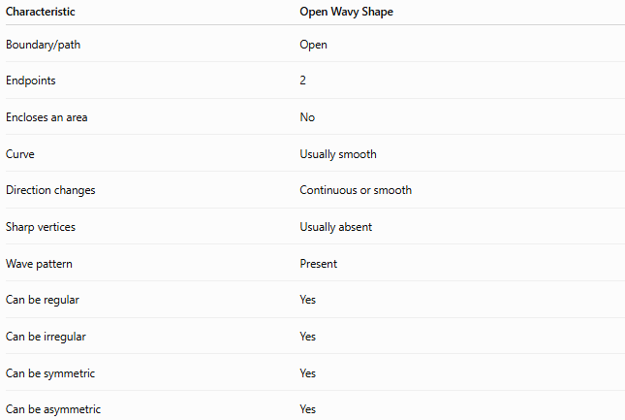
Characteristic | Open Wavy Shape
Boundary/path | Open
Endpoints | 2
Encloses an area | No
Curve | Usually smooth
Direction changes | Continuous or smooth
Sharp vertices | Usually absent
Wave pattern | Present
Can be regular | Yes
Can be irregular | Yes
Can be symmetric | Yes
Can be asymmetric | Yes

Basic Structure
# Source: AI Source: Provided by: [Data Path: Persons Table -> ID Column: 1, Name_En Column: Motasem Essam] -> From: [ChatGPT] on [7/25/2026]
An open wavy path can be represented by points along a continuous curve:
P₁ ~~~~~ P₂ ~~~~~ P₃ ~~~~~ P₄
The curve begins at $P_{1}$and ends at $P_{4}$, without connecting the endpoints.
Thus:
$$\boxed{\text{Open Wavy Shape}=\text{Wave-like open path}}$$

Types of Open Wavy Shapes
# Source: AI Source: Provided by: [Data Path: Persons Table -> ID Column: 1, Name_En Column: Motasem Essam] -> From: [ChatGPT] on [7/25/2026]
Open wavy shapes can be classified according to their pattern:
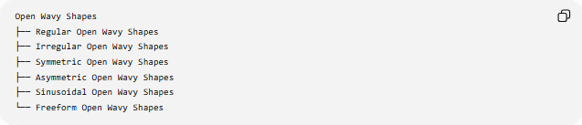
Open Wavy Shapes
├── Regular Open Wavy Shapes
├── Irregular Open Wavy Shapes
├── Symmetric Open Wavy Shapes
├── Asymmetric Open Wavy Shapes
├── Sinusoidal Open Wavy Shapes
└── Freeform Open Wavy Shapes

1-Regular Open Wavy Shapes
# Source: AI Source: Provided by: [Data Path: Persons Table -> ID Column: 1, Name_En Column: Motasem Essam] -> From: [ChatGPT] on [7/25/2026]
A Regular Open Wavy Shape follows a consistent repeating wave pattern.
For example:
$$y=Asin⁡\left(Bx\right)$$
over a selected interval.
╭──╮ ╭──╮
───╯ ╰──────╯ ╰────
The wavelength and amplitude remain consistent.
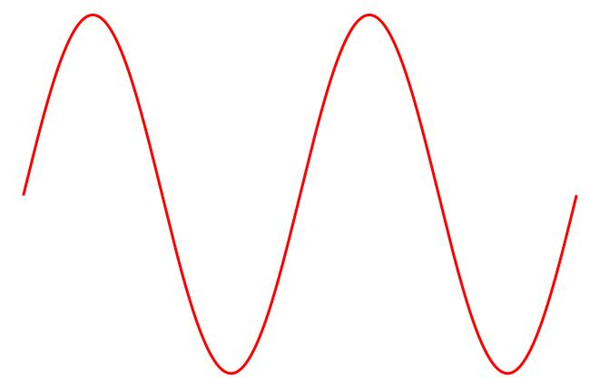
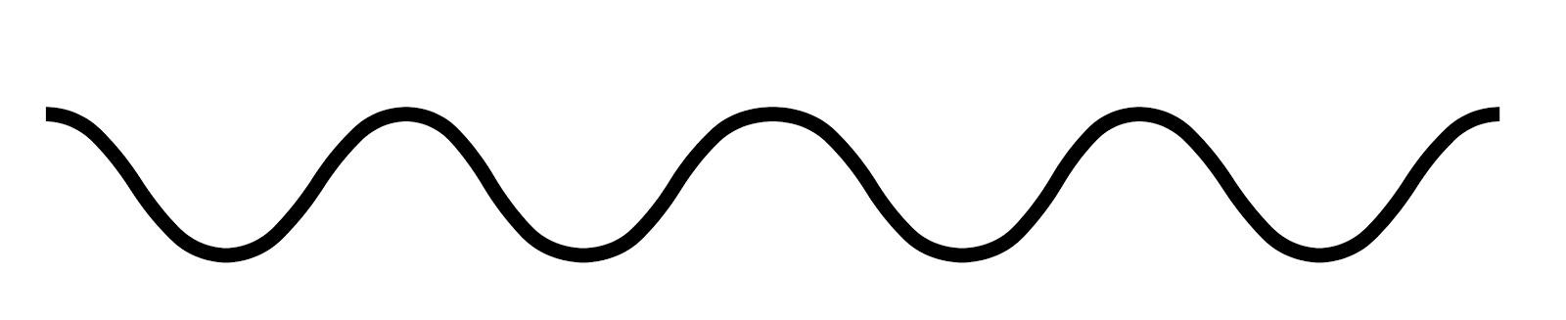
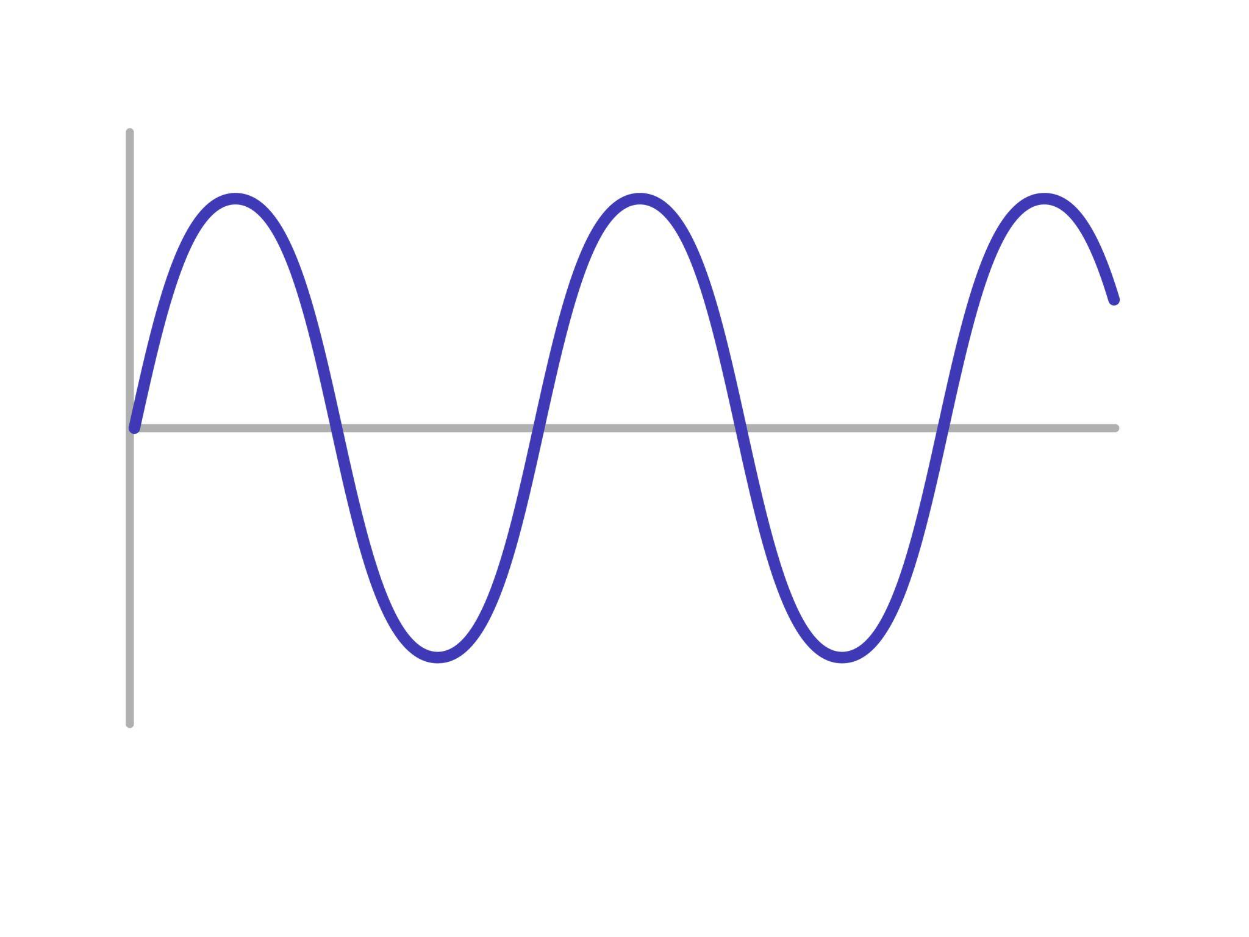
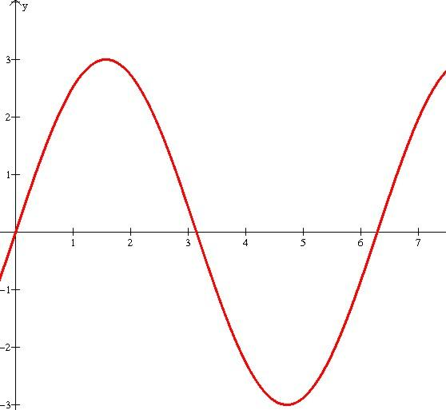

2-Irregular Open Wavy Shapes
# Source: AI Source: Provided by: [Data Path: Persons Table -> ID Column: 1, Name_En Column: Motasem Essam] -> From: [ChatGPT] on [7/25/2026]
An Irregular Open Wavy Shape has varying wave heights, widths, or curvature.
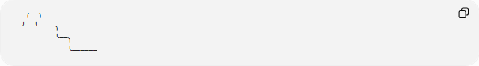
╭──╮
──╯ ╰────╮
╰──╮
╰──────
The wave pattern does not repeat uniformly.

3-Symmetric Open Wavy Shapes
# Source: AI Source: Provided by: [Data Path: Persons Table -> ID Column: 1, Name_En Column: Motasem Essam] -> From: [ChatGPT] on [7/25/2026]
A Symmetric Open Wavy Shape has a symmetry relationship, such as reflection symmetry.
For example, corresponding portions of the curve may mirror each other around a vertical or horizontal axis.

4-Asymmetric Open Wavy Shapes
# Source: AI Source: Provided by: [Data Path: Persons Table -> ID Column: 1, Name_En Column: Motasem Essam] -> From: [ChatGPT] on [7/25/2026]
An Asymmetric Open Wavy Shape does not have the symmetry being considered.
Its wave amplitudes, wavelengths, or overall arrangement may differ from one side to another.

5-Sinusoidal Open Wavy Shapes
# Source: AI Source: Provided by: [Data Path: Persons Table -> ID Column: 1, Name_En Column: Motasem Essam] -> From: [ChatGPT] on [7/25/2026]
A Sinusoidal Open Wavy Shape follows a sine or cosine function, such as:
$$y=Asin⁡\left(Bx+C\right)+D$$
where:
- $A$= amplitude
- $B$= frequency factor
- $C$= phase shift
- $D$= vertical shift

6-Freeform Open Wavy Shapes
# Source: AI Source: Provided by: [Data Path: Persons Table -> ID Column: 1, Name_En Column: Motasem Essam] -> From: [ChatGPT] on [7/25/2026]
A Freeform Open Wavy Shape has a smooth wave-like appearance without following a fixed mathematical wave equation.
It may be designed artistically or occur naturally.
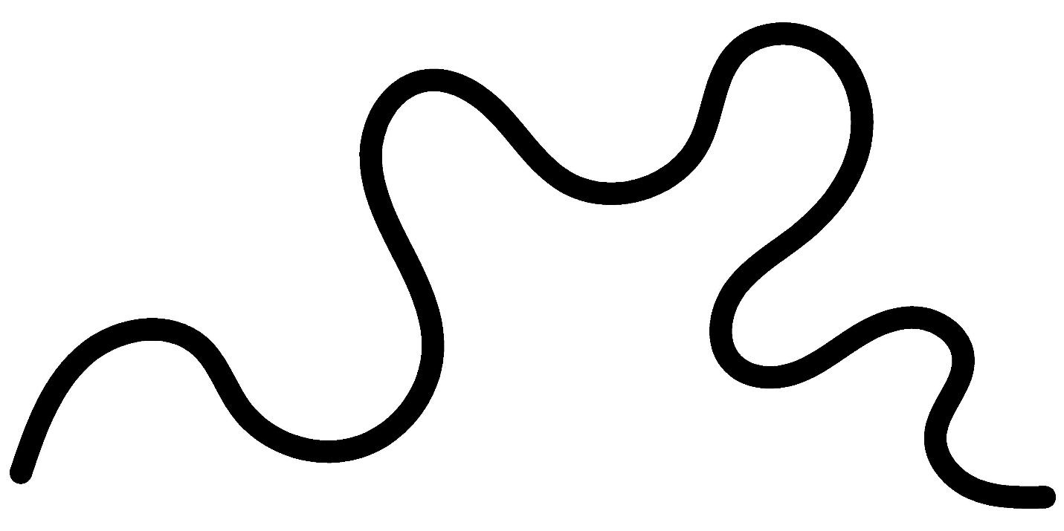
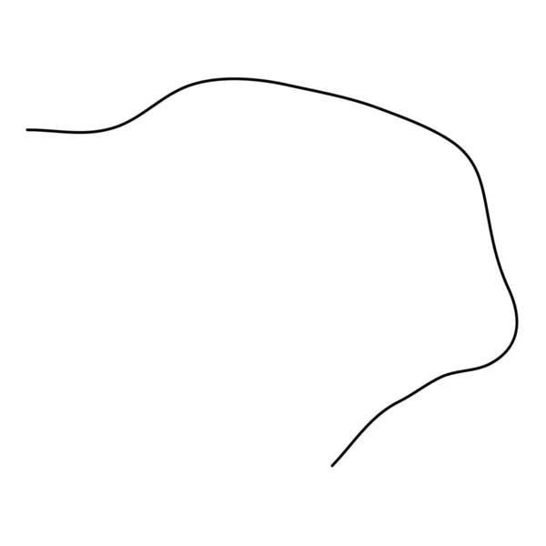
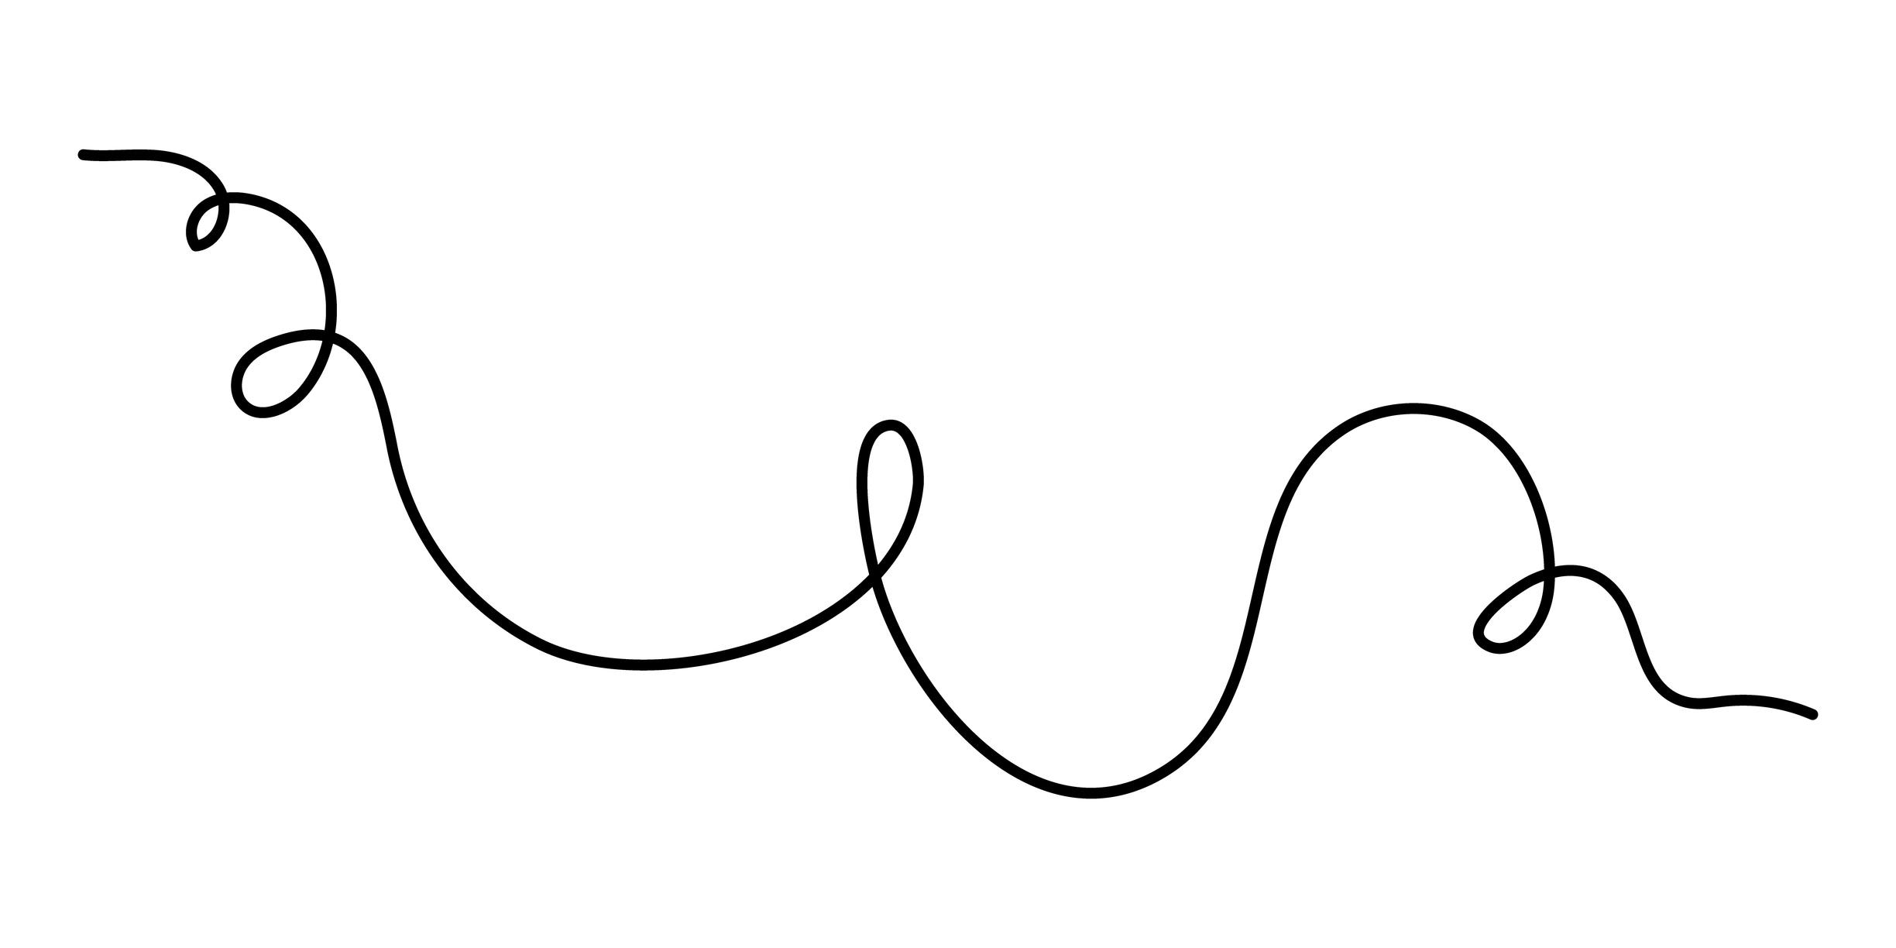
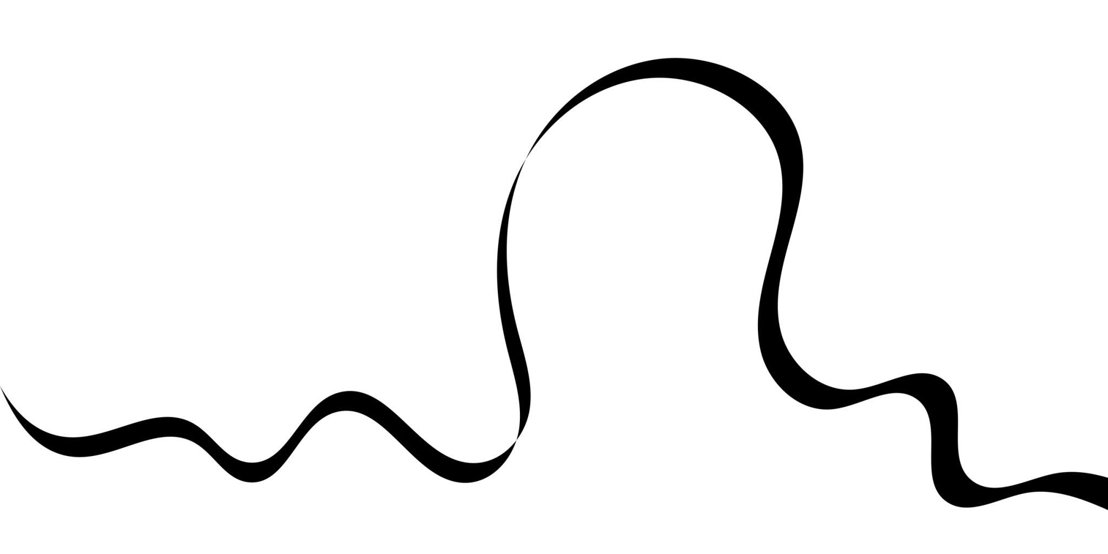
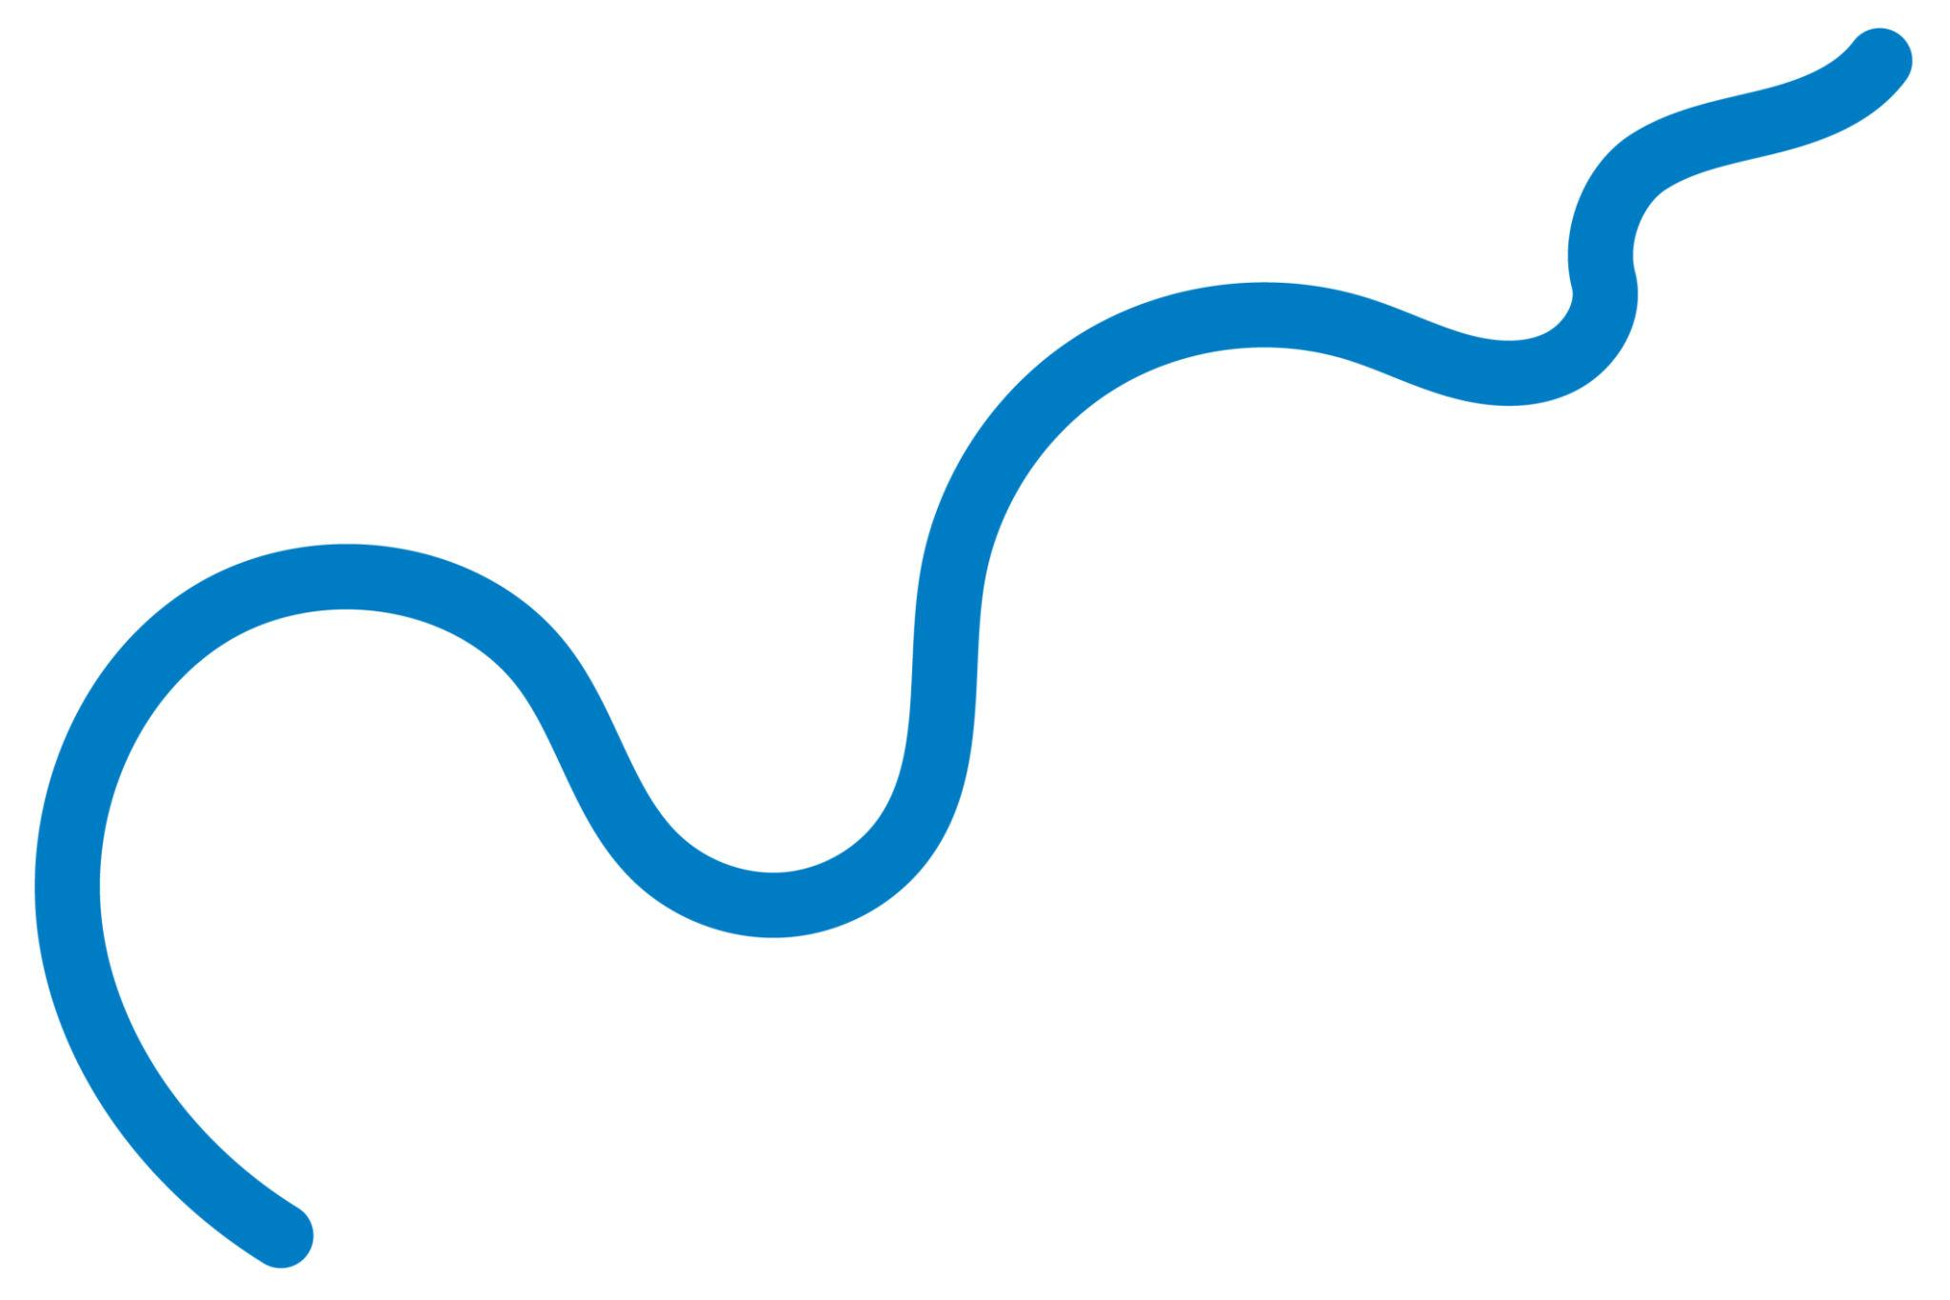
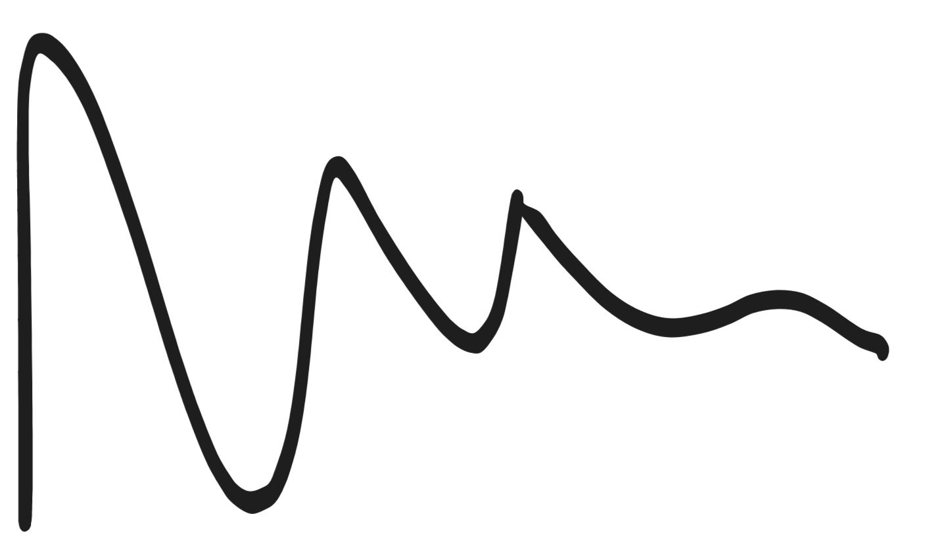

Mathematical Properties
# Source: AI Source: Provided by: [Data Path: Persons Table -> ID Column: 1, Name_En Column: Motasem Essam] -> From: [ChatGPT] on [7/25/2026]
Length
Unlike a straight line segment, the length of a wavy curve generally cannot be found simply by subtracting its endpoint coordinates.
For a curve
$$y=f\left(x\right)$$
from $x=a$to $x=b$, its arc length is:
$$\boxed{L=\int_{a}^{b}{\sqrt{1+{\left(\frac{dy}{dx}\right)}^{2}}} dx}$$
Endpoints
An open wavy curve has two endpoints:
$$\boxed{P_{1}≠P_{2}}$$
The endpoints are not connected.
Area
An open wavy line by itself does not enclose an area.
An area can be defined only when the curve is combined with another boundary, such as:
- a straight line,
- another curve,
- or additional connecting segments.

Open Wavy Shape vs. Closed Wavy Shape
# Source: AI Source: Provided by: [Data Path: Persons Table -> ID Column: 1, Name_En Column: Motasem Essam] -> From: [ChatGPT] on [7/25/2026]
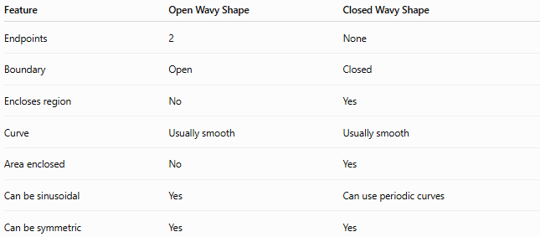
Feature | Open Wavy Shape | Closed Wavy Shape
Endpoints | 2 | None
Boundary | Open | Closed
Encloses region | No | Yes
Curve | Usually smooth | Usually smooth
Area enclosed | No | Yes
Can be sinusoidal | Yes | Can use periodic curves
Can be symmetric | Yes | Yes
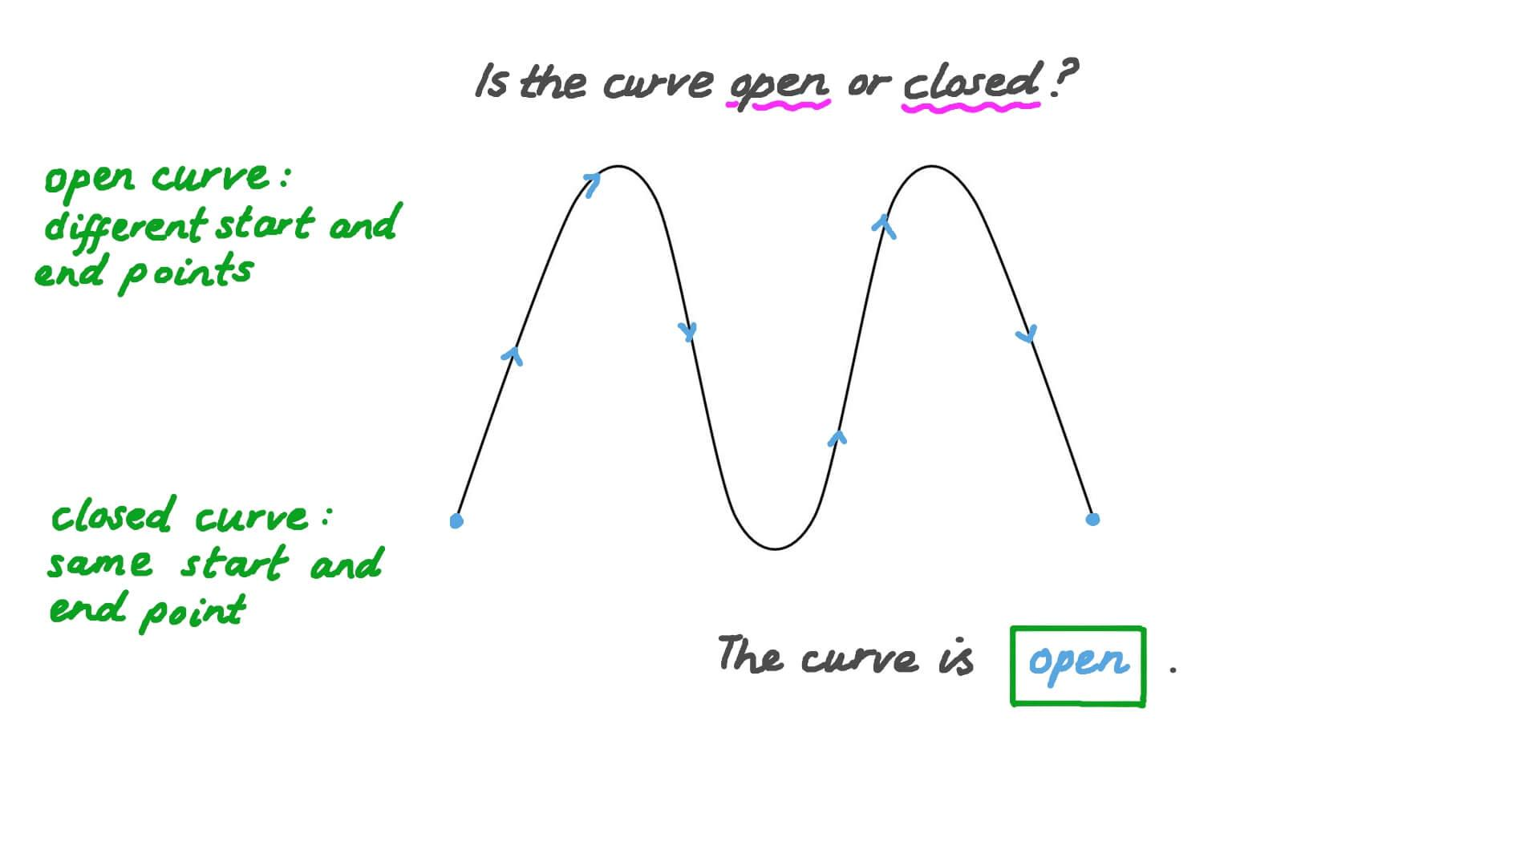
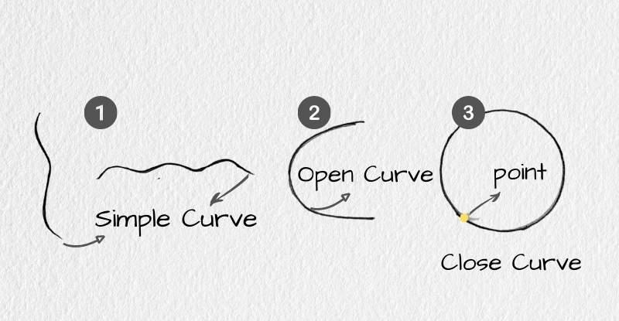
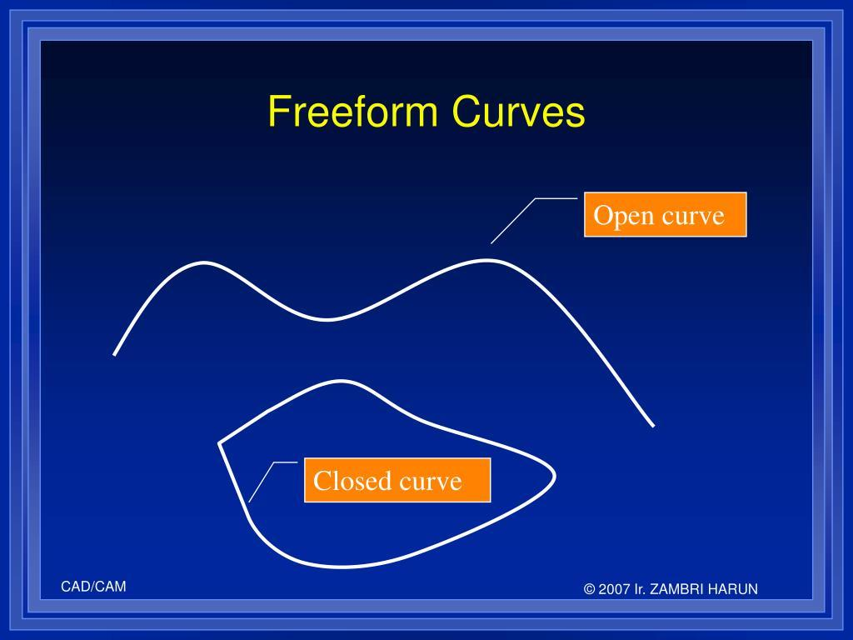
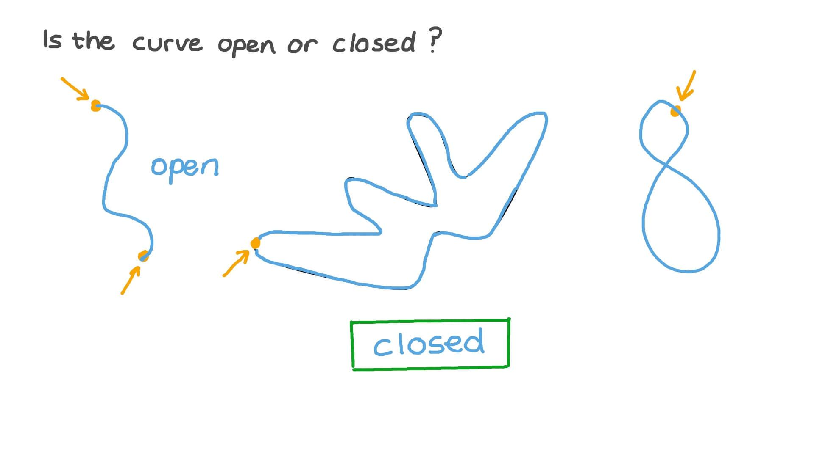

Open Wavy Shape vs. Open Zigzag Shape
# Source: AI Source: Provided by: [Data Path: Persons Table -> ID Column: 1, Name_En Column: Motasem Essam] -> From: [ChatGPT] on [7/25/2026]
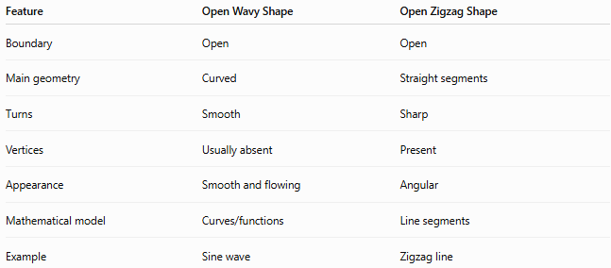
Feature | Open Wavy Shape | Open Zigzag Shape
Boundary | Open | Open
Main geometry | Curved | Straight segments
Turns | Smooth | Sharp
Vertices | Usually absent | Present
Appearance | Smooth and flowing | Angular
Mathematical model | Curves/functions | Line segments
Example | Sine wave | Zigzag line
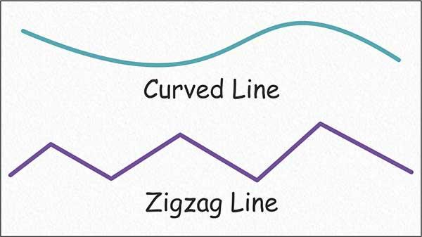
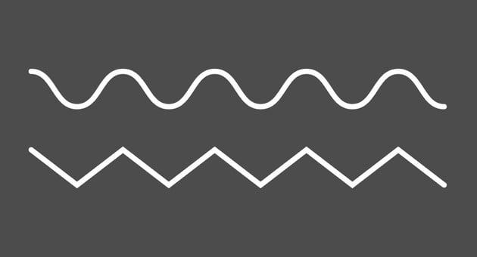
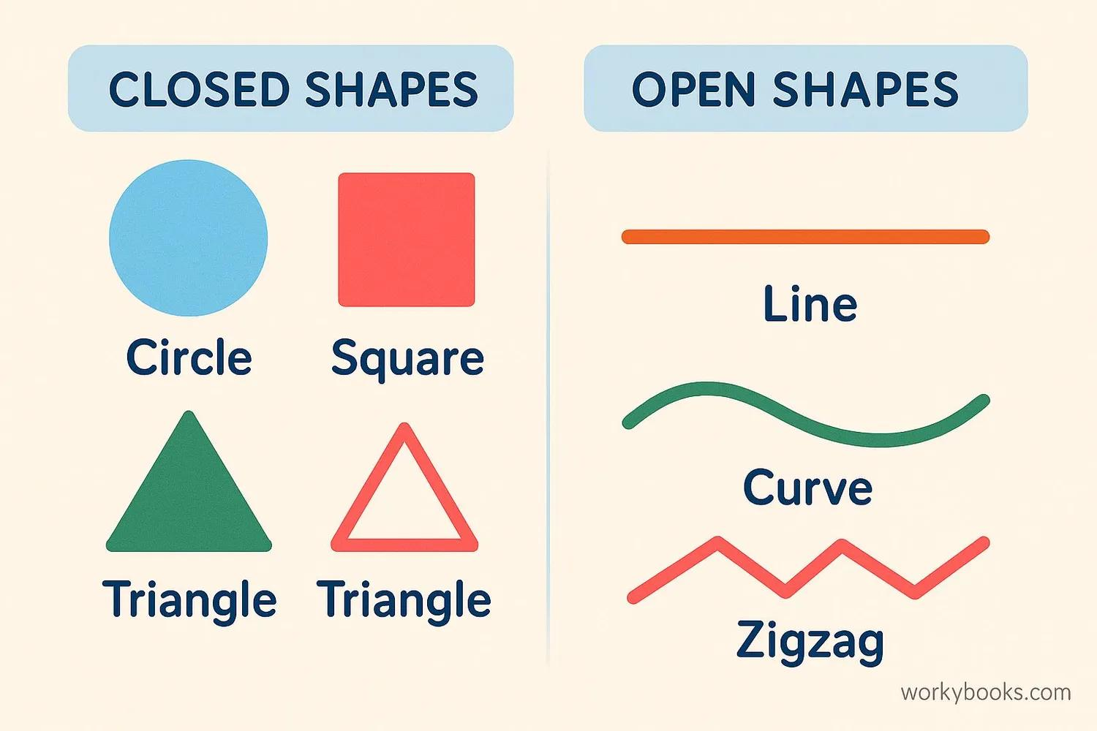
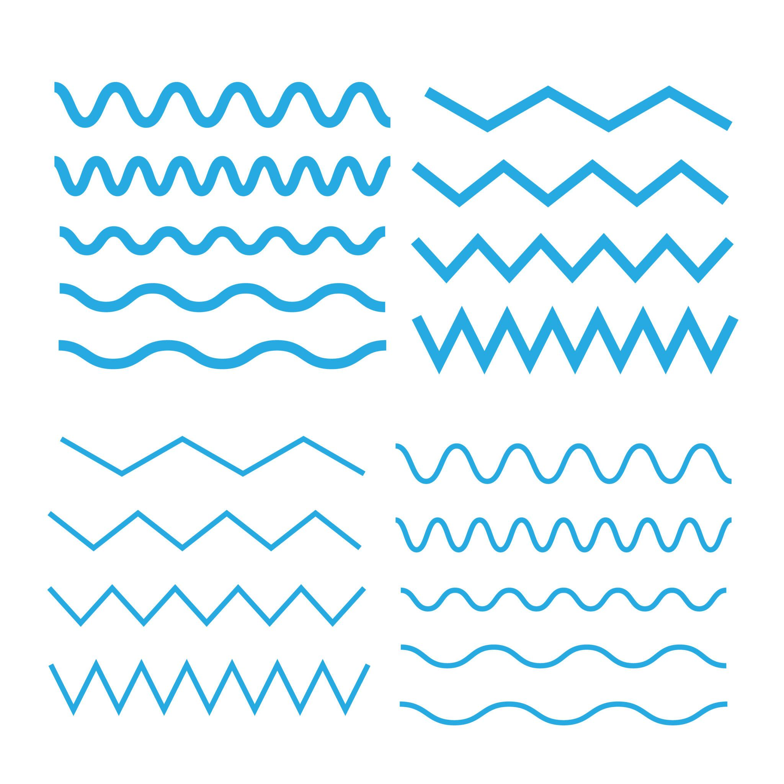

Examples

Example 1 – Simple Open Wavy Shape
# Source: AI Source: Provided by: [Data Path: Persons Table -> ID Column: 1, Name_En Column: Motasem Essam] -> From: [ChatGPT] on [7/25/2026]
────╮ ╭────
╰────╯
The curve has two endpoints and does not close.

Example 2 – Regular Open Wavy Shape
# Source: AI Source: Provided by: [Data Path: Persons Table -> ID Column: 1, Name_En Column: Motasem Essam] -> From: [ChatGPT] on [7/25/2026]
$$y=\sin{x}$$
over a finite interval.
╭╮ ╭╮
───╯ ╰────╯ ╰───

Example 3 – Irregular Open Wavy Shape
# Source: AI Source: Provided by: [Data Path: Persons Table -> ID Column: 1, Name_En Column: Motasem Essam] -> From: [ChatGPT] on [7/25/2026]
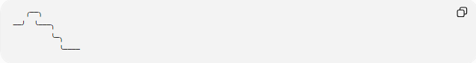
╭──╮
──╯ ╰───╮
╰─╮
╰────
The wave amplitude and spacing vary.

Classification Summary
# Source: AI Source: Provided by: [Data Path: Persons Table -> ID Column: 1, Name_En Column: Motasem Essam] -> From: [ChatGPT] on [7/25/2026]
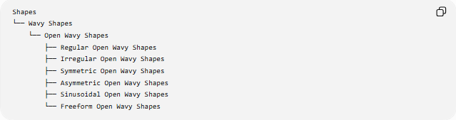
Shapes
└── Wavy Shapes
└── Open Wavy Shapes
├── Regular Open Wavy Shapes
├── Irregular Open Wavy Shapes
├── Symmetric Open Wavy Shapes
├── Asymmetric Open Wavy Shapes
├── Sinusoidal Open Wavy Shapes
└── Freeform Open Wavy Shapes
These classifications can overlap. For example, an open wavy shape can simultaneously be regular + sinusoidal + symmetric.

Key Points
# Source: AI Source: Provided by: [Data Path: Persons Table -> ID Column: 1, Name_En Column: Motasem Essam] -> From: [ChatGPT] on [7/25/2026]
- An Open Wavy Shape is a wave-like curve that does not close.
- It has two distinct endpoints.
- It normally has a smooth curved boundary rather than sharp corners.
- It does not enclose an area by itself.
- It may be regular or irregular.
- It may be symmetric or asymmetric.
- A sinusoidal open wave can be represented by:
$$\boxed{y=Asin⁡\left(Bx+C\right)+D}$$
- The length of a general smooth curve can be calculated using an arc-length integral.

Conclusion
# Source: AI Source: Provided by: [Data Path: Persons Table -> ID Column: 1, Name_En Column: Motasem Essam] -> From: [ChatGPT] on [7/25/2026]
An Open Wavy Shape is an open, smooth, wave-like curve with two endpoints and no enclosed region. It can take regular mathematical forms such as sine waves or irregular freeform forms, and it can possess different symmetry properties.

